Greetings ladies.
Herewith is the link for the Women Pilots 99s - Washington DC Chapter meeting.
First Monday, December 1, 2025, 7:30 – 8:30 PM. Lucia Mencia is inviting you to a scheduled Zoom meeting.
Topic: Women Pilots 99s - Washington DC Chapter. Events past, present, future.
Time: This is a recurring meeting, first Monday, each month.
https://us05web.zoom.us/j/88487404268?pwd=OXlXWnppSmM3Tncwb2dLT3JscjZJdz09
Meeting ID: 884 8740 4268; Passcode: zsu6ef.
Washington DC Chapter
Women Pilots 99s

General news: AGENDA topics for meeting: Participants via Zoom:
- Chairman: Lucy Mencia
- Vice Chairman: Laura Takacs has been full of energy and great ideas to re-vitalize the internet presence. Laura has worked very hard to present the Bev Sharp award internet information and auction. Her efforts have been very productive to promote this award and auction. Thank you.
- Treasurer: Linda Litwin graciously agreed to continue to serve as Treasurer. Yearly chapter donation dues in the amount of $20 were due by December 1, 2025. Please send in your contributions: Venmo: @WashingtonDC-Ninety-Nines or to Linda Litwin, Washington DC Chapter Treasurer.
- Secretary, and Director of Events Planning: Veronica Knurenko. She will be planning monthly fly out events. Please suggest possible up coming local events and fly out locations.
- Secretary, and Director of Communications: Caren M. Roushkolb has agreed to work on IT and Communications standing. She is a visionary about different new internet platforms and will try to tackle the task to promote the Washington DC chapter in other platforms. Thank you.
- Membership Chair: Kathleen O’Neil is our Membership chair position. The Washington DC Chapter membership report as of Dec/2024, the Wash DC Chapter has 41 members who are registered.
She graciously sends invitations and welcome letters to new members. Thank you.
Scholarships Chair: Pat Manos has agreed to continue to serve in the Education chair position.
She is an active CFI and past AE winner, with many ideas about scholarships. Thank you.
- Special Event Chair: Barbara Rhode has taken the lead in organizing the Bev Sharp Award. Thank you.

Internet re-balancing efforts: Our mission statement as Ninety Nines is to promote aviation studies, especially amongst young women pilots. The Washington DC Facebook and Instagram should reflect the adventures and accomplishments of the DC members. We will be highlighting many flying adventures around the area that young women will want to join. We now have a greatly improved Washington DC 99s Facebook page: https://www.facebook.com/DC99s/ also at www.dc99s.com also an Internet account. Thank you Laura and Caren.

Scholarships Available: Pat reminds all of us that there are many other scholarships out there that need good homes. Are you in search of the perfect scholarship to meet your aviation goals? Check out our scholarship database, now live on the DC99s website. And remember all junior birds, feel free to call on any of the senior birds of the Washington DC 99s chapter to help you read and edit your applications. Pat and Sandra, both past AE judges will be able to provide good writing prose advice. https://www.dc99s.com/scholarships
#aviation #scholarships #aviatrix #ninetynines #flighttraining #learntofly #wai #ladyaviators

The Ninety-Nines, Inc. offers various scholarships for women pilots, including the
Amelia Earhart Memorial Scholarship Fund, which provides advanced training and education in aviation and aerospace. Additionally, several chapters and sections of The Ninety-Nines offer their own scholarships. For example, the Greater Seattle 99s offers a $3,000 scholarship for student pilots pursuing a Private Pilot Certificate, with applications due April 18, 2025. The Georgia Flying Belles Chapter offers three scholarships in 2025, including one for $6,500 for a chapter member towards any rating or certificate. Besides our own Ninety Nines, there are several organizations that offer flight scholarships for 2025, with varying deadlines and eligibility requirements:

The EAA Flight Training Scholarships are a good starting point, with applications opening November 1, 2025, and awarding over $135,000 annually. Also, remember that they have VERY interesting free lectures about all sorts of topics: cross country planning, engine maintenance, Personal minimums, the MOSAIC new rules.

AOPA offers scholarships with varying amounts, due February 7, 2025, and open to AOPA members.
Range from $2,500 to $14,000. Open to AOPA members who are U.S. citizens or permanent legal residents.
Support primary flight training, advanced ratings/certificates, and aviation maintenance. AOPA application period opened on Oct 3 and closes at Dec 31. They remind us:
“CFI’s tell your students and clients about the AOPA Foundation Scholarship program. Or check it out for yourself! NEW! Two application periods. More chances for AOPA members to achieve their aviation goals. Scholarships for High School Students
Since 2019, the Ray Foundation has generously provided $1 million annually in flight training scholarships. This year, 90 high school students will receive $12,000 each to pursue their private pilot certificate. To be eligible, students must be AOPA members—and AOPA offers a free High School Membership for students aged 13 to 20, making it easy to get started and take advantage of this opportunity. Scholarships for Aspiring and Experienced Pilots AOPA’s aviation scholarships are tailored to support a variety of goals, including primary certification, advanced ratings, transitioning to a new aircraft, or specialized training. Applications are Open! All CFI’s, encourage your students and clients to visit aopa.org/scholarships. The deadline for the fall application period is December 31, 2025. Notifications to recipient winners in Feb 2026”.

Women in Aviation International (WAI) also has scholarships with deadlines in October and notifications in December. Applications had to be submitted by October 15, 2025. Winners are notified by December 15, 2025.
WAI does not consider race, ethnicity, or gender in awarding scholarships.

- WE ARE VERY PROUD OF OUR OWN Kathleen O’Neil Her ATP-multi is complete!
Thanks to the great King Air team at CAE Dallas, especially Jimmie Key, Josh Sallee, Walter Mercer, Robert Bloom and SIC help from Gary Hebsacker and Tera Pennock. We are very proud of her efforts and commitment. She is now an ATP, commercial pilot, Flight instructor. Yeay. Well done Kathleen. !

- WE ARE VERY PROUD OF OUR OWN Veronika Knurenko who has offered to start a new initiative “Tuesdays with Veronika” from 8PM – 9 PM. to help the Ninety Nines in a Question and Answers program. Veronika has been in contact with the Mid Atlantic group. The Washington DC Chapter will support her initiative and help to advertise this forum. Thank you Veronika.

Ground School Registration for VFR: Notice from Chesapeake Sports Pilots (Bay Bridge KW29), where we re-painted their compass rose: Registration is now open for VFR ground school. This fantastic class will again be taught by renowned CSP AGI Kathy Harkness over Zoom, on Monday and Thursday evenings at 7:30 starting January 26th. This class is perfect for those of you studying for VFR ratings such as sport pilot, private, commercial or CFI. It's also a great refresher for rusty pilots. Click here for more information or to sign up.

Treasurer’s Report of December 2025: Status of our two (2) accounts (update these to 11/25).
- BEV SHARP Award ACCOUNT 1765.00 Balance as of 10/30/25
-1000.00 Disbursed/sent to International Ninety Nines: 11/01/25
TOTAL $765.00 New balance, in BS account: 11/01/25

- Washington DC Chapter ACCOUNT TOTAL $120.00 Balance, in WDC account: 11/01/25

We need to maintain these two accounts to make sure to separate donations from donors to this BS non profit Award. We need not to combine this Award with “operating” budgets; this for IRS reporting rules.

« CALL FOR PAYMENT OF DUES: Our devoted Treasurer is again requesting that ALL of us contribute our yearly $20.00 dues; this is an amount that has remained stable for ten? years. Many of us are delinquent. That should be a normal Yearly chapter donation for all of us. Please send in your contributions:
Venmo: @WashingtonDC-Ninety-Nines or, Address for Check: Linda Litwin, Washington DC Chapter Treasurer, 11509 Bedfordshire Ave, Potomac, MD 20854.

« Meeting Time Change. It was Voted that a change to 7:30 PM was voted and agreed. So we will delay the First Monday of each Month meeting to change to new 7:30 PM to 8:30 PM time.
This was agreed to by unanimous vote, with no objections.

I Ongoing General Aviation Events : Women Pilots 99s - Washington DC Chapter:

Bev D. Sharp Aviation Outreach Award. - Recurring and NEW topics of interest:

« It was agreed that we would change the name to: “ The Bev D. Sharp Aviation Outreach Award”. This was considered to be a “less confrontational title which would allow more funding donations. It was reported that some potential donors are staying away from this Award due only to the DEI name. Barbara is in agreement with this name change. The leadership, direction and intention of the BDS Aviation Outreach Award remains the same. We still have funding issues. Maybe Robin could contribute the printing costs? Mr. Sharp? Sen Duckworth? Or other sources. New focused donation plans now that we have a new name. TBD

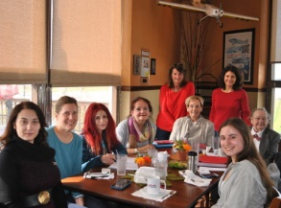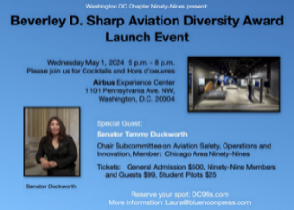

Bev D. Sharp Aviation Outreach Award Updates: Barbara led a meeting on Monday October 27, 2025. Barbara informed the group about progress. Dr. Pat Manos talked with Dr. Minetta Gardinier about next steps. Pat reported that she had been in touch with Minetta. Minetta provided a sample form which we will copy. Our Bev D. Sharp Aviation Outreach Award will be similar in style and organization as nine (9) other Ninety Nines Awards, including the George Puttnam Award and the Catherine Wright Award. The selection of winners would be done by the Ninety Nines. There is ongoing cooperation between the International Board of Directors in Oklahoma City and our Washington DC Chapter.

Debi represented us at the Governors’ meeting which was held Nov 7-8, 2025.
(PS Debi made HISTORY!!: In the entire history of FAA recorded flight, NO ONE ELSE has ever flown Bahamas to Oklahoma City, Ok. We are so proud of our ground sky breaking aviatrix. Report on events?

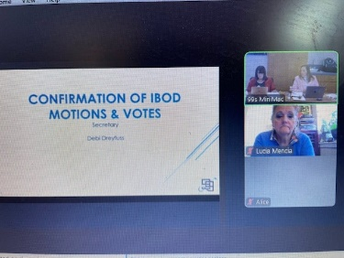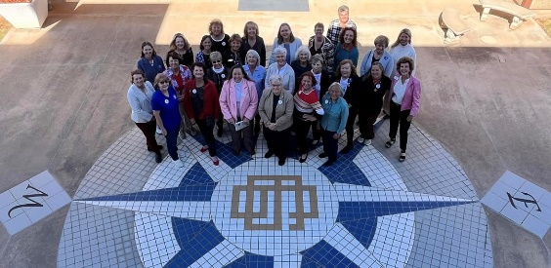

II Past – Last month’s November aviation events:
November xx TBD. Talk – has been postponed due to scheduling difficulties with the with speaker. We still will have the talk at GAI, possibly at Gold’s Gym or at Sophie’s Café at GAI. The topic is to be “Over Atlantic crossing, in C172 from Israel to KGAI”. We are hoping to reschedule next year but need to do invitations.
November 8 Saturday 10: AM . – has been postponed due to the government closure of Smithsonian. This is to be a VIP Behind the scenes Tour of Udvar Hazy restoration Facility. Udvar Hazy is a Smithsonian museum and hence all activities, including tours, were cancelled. We will try to reschedule when/if sanity is restored in Washington DC.

III. Future GA aviation events: This month’s December events:
SEASONS GREETINGS TO ALL. (General Aviation Version of Clement Moore’s poem):
'Twas the night before Christmas, and out on the ramp, Not an airplane was stirring, not even a Champ.
The aircraft were fastened to tie downs with care, In hopes that -- come morning -- they all would be there.
The fuel trucks were nestled, all snug in their spots, With gusts from two-forty at 39 knots.
I slumped at the fuel desk, now finally caught up, And settled down comfortably, resting my butt.
When the radio lit up with noise and with chatter, I turned up the scanner to see what was the matter.
A voice clearly heard over static and snow, Called for clearance to land at the airport below.
He barked his transmission so lively and quick, I'd have sworn that the call sign he used was "St. Nick."
I ran to the panel to turn up the lights, The better to welcome this magical flight.
He called his position, no room for denial, "St. Nicholas One, turnin' left onto final."
And what to my wondering eyes should appear, But a Rutan-built sleigh, with eight Rotax Reindeer!
With vectors to final, down the glideslope he came, As he passed all fixes, he called them by name:
"Now Ringo! Now Tolga! Now Trini and Bacun !On Comet! On Cupid!" What pills was he takin'?
While controllers were sittin', and scratchin' their heads, They phoned to my office, and I heard it with dread,
The message they left was both urgent and dour:" When Santa pulls in, have him please call the tower."
He landed like silk, with the sled runners sparking, Then I heard, "Left at Charlie," and "Taxi to parking."
He slowed to a taxi, turned off of three-oh, And stopped on the ramp with a "Ho, ho-ho-ho..."
He stepped out of the sleigh, but before he could talk, I ran out to meet him with my best set of chocks.
His red helmet and goggles were covered with frost, And his beard was all blackened from Reindeer exhaust.
His breath smelled like peppermint, gone slightly stale ,And he puffed on a pipe, but he didn't inhale.
His cheeks were all rosy and jiggled like jelly ,His boots were as black as a crop-duster's belly.
He was chubby and plump, in his suit of bright red, And he asked me to "fill it, with hundred low-lead."
He came dashing in from the snow-covered pump, I knew he was anxious for draining the sump.
I spoke not a word, but went straight to my work, And I filled up the sleigh, but I spilled like a jerk.
He came out of the restroom, and sighed in relief, Then he picked up a phone for a Flight Service brief.
And I thought as he silently scribed in his log, These reindeer could land in an eighth-mile fog.
He completed his pre-flight, from the front to the rear, Then he put on his headset, and I heard him yell, "Clear!"
And laying a finger on his push-to-talk, He called up the tower for clearance and squawk.
"Take taxiway Charlie, the southbound direction, Turn right three-two-zero at pilot's discretion."
He sped down the runway, the best of the best, "Your traffic's a Mooney, inbound from the west."
Then I heard him proclaim, as he climbed thru the night,
"Merry Christmas to all! I have traffic in sight."
« December 4 Thursday. HOLIDAY PARTY at College Park Aviation Museum. We have already reserved, along with the pilots from EAA-4 College Park (the pilots who organize the yearly Oshkosh) for the Mezzanine space at College Park Aviation Museum. There will be music, food, flying inspired frivolity. Maybe a Flying Jeopardy or Trivia game. This is a pot luck event. Please mark your calendars for Dec. 4, Thursday.

We need pot luck food donations. College Park Aviation Museum (mezzanine) 7 PM -9 PM. Free.

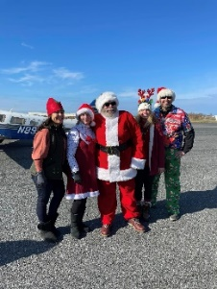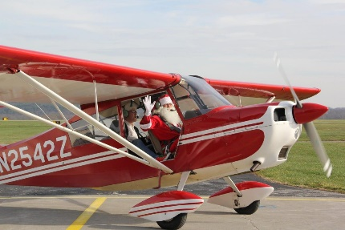
Decorated Ninety Nines Santa-elves On Dec 3, 2023 Santa came in a Piper.

« December 6 Saturday. Tangier Island Holly Run. Subject to weather conditions with a rain/snow date of December 13, Saturday. This is a flight from W29 Bay Bridge to TGI Tangiers Island to bring holly, toys and books for the school children. This is Helen’s yearly charity event where many of the local pilots, (led by Fred – dressed as Santa) in his Mooney, with assorted decorated pilot elves lead the pilots flotilla for this lively event. This is your yearly chance to wear your “ugly holiday sweater”. Yes, the Mooney is red (SO for that flight, Santa’s Mooney is “Rudolph One”. Really. We need to start collecting toys and school supplies for the children so to be prepared to participate in this holiday charity fly out.
This is our Washington DC Chapter’s December WDC Chapter fly-out.

Coordination: The planes meet at the W29 hangar and get pre-flight instructions from Helen. Flotilla planes are assigned staggered fly out times depending on the speed of each airplane, (to allow the TGI runway elves to park the planes). This is a VERY coordinated event, with TRACON and local control towers aware of this sudden invasion to the tiny TGI island. You must register and attend the morning’s pilot chat.

Lunch: There are a few lovely places to have lunch, including the oldest, “Loranines” known for oyster dishes. Due to the sudden invasion of pilots, our arrival at the various restaurants must be coordinated. The local minister has an ecumenical prayer service at the ?lone? religious structure which has a lovely white wood historic bell spire.

Due to global warming, the island is sinking into Chesapeake Bay and the permanent census of the island decreases each year. There is NO medical attendant on the island. It is not a solution to simply raise the houses (most which are now out of plumb and sagging) but it is a question of completely revamping the infrastructure, plumbing, water supply, electric connections. Meanwhile there are completely NEW man-made islands at golf course at Haines Point, expensive luxury housing in Dubai, airport in Taiwan and luxury housing Fisher Island in the Miami Florida bay. Even to re-do the infrastructure is a costly notion that has no financial backing in MD so KTGI’s days are numbered. These solutions require major land fill, expensive concrete sea walls, and EPA and government backing for these projects; With the dwindling census at TGI, the MD votes are not present.

December 13, Saturday 8:45 AM - Santa arrives at FDK airport - festival. NACC building, KFDK. Santa (suspiciously similar to Carlo) and Mrs Santa (suspiciously similar to Lin) will be present to be merry, cheerful and bright. Last year there were fancifully decorated elves (suspiciously similar to Brenda and Beth) who provided merriment. And, remember, KFDK is a delightful historic old city; nice to see as a Fly out.



Various Marines Toys for Tots Fly-Outs - support, in cooperation with other groups:
- 2025 Toys for Tots Fly Out October 18, 2025 with the Hampton Roads Radio Control, Inc. group.
- Toy Fly Out - Marines Toys for Tots Foundation with the Old Dominion Freight Line Inc. group.
Throughout the year, they hosted 65 toy collection campaigns, collected 7,125 toys, 41 bicycles, and an additional $8,110 in cash donations. — all of which are making their way to children in need. Beyond these efforts by the ODFL, Old Dominion Freight Lines also generously transported many of the toys we distribute and has been a longstanding National Corporate Sponsor of Toys for Tots! The Marines Toys for Tots was grateful for the support of the organization, whose partnership helps them spread hope and joy to children in need.

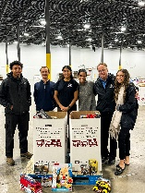

Other future events:
May 2026 - Mid Atlantic Spring Section meeting – (hosted MD chapter)
July 6-12 2026 - International Conference meeting. San Diego, CA (hosted by the SW Section)
October 2027 - International meeting Sydney, Australia (hosted by the Australia Section).

Puppy Rescue: Race 4 Life Rescue did a remarkable job rescuing shelter pets and flying supplies to hurricane-impacted areas. Volunteers needed to fly airport-legs to save puppies, (and full grown) from hurricane affected areas. Questions to Erin Miller. Learn more about them here: https://raceforliferescue.org/.
Hurricane Helene and Jamaica relief: The Operation Air drop pilots is working with individual donation groups to do emergency flights to assist needy residents of the Ashville, NC and of the Jamaica areas. Hurricane Helene has caused much destruction and GA airplanes have been asked to help drop off needed supplies. https://www.operation-airdrop.com/hurricane-helene. We have been asked to donate GA flight time.

FLYOUTS and aviation events schedules:
To be as inclusive as possible, and to promote all women pilots and student pilots, we extend a flyout invitation to the sister Sugarloaf 99s and to the Bravo Flight School should they want to join the fly outs. I reached out to Lin Caywood, Sugarloaf Chairman and she was in support of joint fly outs. TBD.
Next Washington DC Chapter Meeting: First Monday of January 5, 2025, via Zoom at 7:30 PM.
End of agenda. *************

