Greetings ladies.
Herewith is the link for the Women Pilots 99s - Washington DC Chapter meeting.
First Monday, January 5, 2025, 7:30 – 830 PM. Lucia Mencia is inviting you to a scheduled Zoom meeting.
Topic: Women Pilots 99s - Washington DC Chapter. Events past, present, future.
Time: This is a recurring meeting, first Monday, each month.
https://us05web.zoom.us/j/88487404268?pwd=OXlXWnppSmM3Tncwb2dLT3JscjZJdz09
Meeting ID: 884 8740 4268; Passcode: zsu6ef.
Washington DC Chapter
Women Pilots 99s

General news: AGENDA topics for meeting: Participants via Zoom:
- Chairman: Lucy Mencia
- Vice Chairman: Laura Takacs has been full of energy and great ideas to re-vitalize the internet presence. Laura has worked very hard to present the Bev Sharp award internet information and auction. Her efforts have been very productive to promote this award and auction. Thank you.
- Treasurer: Linda Litwin graciously agreed to continue to serve as Treasurer. Yearly chapter donation dues in the amount of $20 were due by December 1, 2025. Please send in your contributions: Venmo: @WashingtonDC-Ninety-Nines or to Linda Litwin, Washington DC Chapter Treasurer.
- Secretary, and Director of Events Planning: Veronica Knurenko. She will be planning monthly fly out events. Please suggest possible up coming local events and fly out locations.
- Secretary, and Director of Communications: Caren M. Roushkolb has agreed to work on IT and Communications standing. She is a visionary about different new internet platforms and will try to tackle the task to promote the Washington DC chapter in other platforms. Thank you.
- Membership Chair: Kathleen O’Neil is our Membership chair position. The Washington DC Chapter membership report as of Dec/2024, the Wash DC Chapter has 42 members who are registered.
She graciously sends invitations and welcome letters to new members. Thank you.
Scholarships Chair: Pat Manos has agreed to continue to serve in the Education chair position.
She is an active CFI and past AE winner, with many ideas about scholarships. Thank you.
- Special Event Chair: Barbara Rhode has taken the lead in organizing the Bev Sharp Award. Thank you.

Internet re-balancing efforts: Our mission statement as Ninety Nines is to promote aviation studies, especially amongst young women pilots. The Washington DC Facebook and Instagram should reflect the adventures and accomplishments of the DC members. We will be highlighting many flying adventures around the area that young women will want to join. We now have a greatly improved Washington DC 99s Facebook page: https://www.facebook.com/DC99s/ also at www.dc99s.com also an Internet account. Thank you Laura and Caren.

Scholarships Available: Pat reminds all of us that there are many other scholarships out there that need good homes. Are you in search of the perfect scholarship to meet your aviation goals? Check out our scholarship database, now live on the DC99s website. And remember all junior birds, feel free to call on any of the senior birds of the Washington DC 99s chapter to help you read and edit your applications. Pat and Sandra, both past AE judges will be able to provide good writing prose advice. https://www.dc99s.com/scholarships
#aviation #scholarships #aviatrix #ninetynines #flighttraining #learntofly #wai #ladyaviators

The Ninety-Nines, Inc. offers various scholarships for women pilots, including the
Amelia Earhart Memorial Scholarship Fund, which provides advanced training and education in aviation and aerospace. Additionally, several chapters and sections of The Ninety-Nines offer their own scholarships. For example, the Greater Seattle 99s offers a $3,000 scholarship for student pilots pursuing a Private Pilot Certificate, with applications due April 18, 2025. The Georgia Flying Belles Chapter offers three scholarships in 2025, including one for $6,500 for a chapter member towards any rating or certificate.
Besides our own Ninety Nines, there are several organizations that offer flight scholarships for 2025, with varying deadlines and eligibility requirements:

Sugarloaf Chapter has announced the winners of their 2025 scholarships.
The Ninety-Nines Sugarloaf Chapter recently announced 2025 scholarship winners: Olivia Fuller (primary) for glider training and Eva Thierry (secondary) for her Private Pilot license. Previous winners include Leah Murphy in 2023, who used the funds for her Multi-Engine Commercial Certificate, supporting her goal of flying professionally. These scholarships help women pursue various aviation goals, from basic certificates to advanced ratings, notes the Mid-Atlantic 99s website.
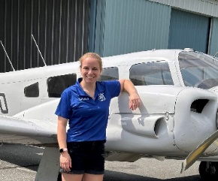

The EAA Flight Training Scholarships are a good starting point, with applications opening November 1, 2025, and awarding over $135,000 annually. Also, remember that they have VERY interesting free lectures about all sorts of topics: cross country planning, engine maintenance, Personal minimums, the MOSAIC new rules.

AOPA offers scholarships with varying amounts, due February 7, 2025, and open to AOPA members.
Range from $2,500 to $14,000. Open to AOPA members who are U.S. citizens or permanent legal residents.
Support primary flight training, advanced ratings/certificates, and aviation maintenance. AOPA application period opened Oct 3 and closes at Dec 31. They remind us:
“CFI’s tell your students and clients about the AOPA Foundation Scholarship program. Or check it out for yourself! NEW! Two application periods. More chances for AOPA members to achieve their aviation goals. Scholarships for High School Students
Since 2019, the Ray Foundation has generously provided $1 million annually in flight training scholarships. This year, 90 high school students will receive $12,000 each to pursue their private pilot certificate. To be eligible, students must be AOPA members—and AOPA offers a free High School Membership for students aged 13 to 20, making it easy to get started and take advantage of this opportunity. Scholarships for Aspiring and Experienced Pilots AOPA’s aviation scholarships are tailored to support a variety of goals, including primary certification, advanced ratings, transitioning to a new aircraft, or specialized training. Applications are Open! All CFI’s, encourage your students and clients to visit aopa.org/scholarships. The deadline for the fall application period is December 31, 2025. Notifications to recipient winners in Feb 2026”.

Women in Aviation International (WAI) also has scholarships with deadlines in October and notifications in December. Applications had to be submitted by October 15, 2025. Winners are going to be notified by December 15, 2025. WAI does not consider race, ethnicity, or gender in awarding scholarships.

WE ARE VERY PROUD OF OUR OWN Kathleen O’Neil Her ATP-multi is complete!
Thanks to the great King Air team at CAE Dallas, especially Jimmie Key, Josh Sallee, Walter Mercer, Robert Bloom and SIC help from Gary Hebsacker and Tera Pennock. We are very proud of her efforts and commitment. She is now an ATP, commercial pilot, Flight instructor. Well done Kathleen ! YEAY.

WE ARE VERY PROUD OF OUR OWN Veronika Knurenko. Her new endeavor link……Here's a link for Tuesday's with Veronika. Questions and Answers. Tuesdays with Veronica from 8-9 PM. This is the link:
https://us06web.zoom.us/j/82701045823?pwd=paeDFdxeqOsfQRN7ujtE6ZhtvYEy4M.1
So far, Veronika has had five sessions that have been very well attended by Ninety Nines. There were many questions. Thanks to the exposure and invitations by Lin Caywood, our Ninety Nines Governor, who provided a link/invitation to the entire Mid-Atlantic Section and chapter heads, there have been a nice group of participants from all over the US: Fullerton California, a student pilot returning from Japan, Old Dominion Chapter, Central PA Chapter, and even one from the Montreal 99s chapter. Viewers represented different levels: Some were students, some prepping for CFI exams, some who just wanted continuing education and one who was pursuing her multi-engine rating. Great presentation with a Q/A period at the end. Good job Veronika. YEAY.

Ground School Registration for VFR: Notice from Chesapeake Sports Pilots (Bay Bridge KW29), where we re-painted their compass rose: Registration is now open for VFR ground school. This fantastic class will again be taught by renowned CSP AGI Kathy Harkness over Zoom, on Monday and Thursday evenings at 7:30 starting January 10th, 2026. This class is perfect for those of you studying for VFR ratings such as sport pilot, private, commercial or CFI. It's also a great refresher for rusty pilots. Click here for more information or to sign up.

Treasurer’s Report of December 2025: Status of our two (2) accounts GET THE Jan 26 $$ FROM LL
- BEV SHARP Award ACCOUNT 1765.00 Balance as of 10/30/25
-1000.00 Disbursed/sent to International Ninety Nines: 11/01/25
TOTAL $765.00 New balance, in BS account: 11/01/25

- Washington DC Chapter ACCOUNT TOTAL $120.00 Balance, in WDC account: 11/01/25

We need to maintain these two accounts to make sure to separate donations from donors to this BS non profit Award. We need not to combine this Award with “operating” budgets; this for IRS reporting rules.

« CALL FOR PAYMENT OF DUES: Our devoted Treasurer is again requesting that ALL of us contribute our yearly $20.00 dues; this is an amount that has remained stable for ten? years. Many of us are delinquent. That should be a normal Yearly chapter donation for all of us. Please send in your contributions:
Venmo: @WashingtonDC-Ninety-Nines or, Address for Check: Linda Litwin, Washington DC Chapter Treasurer, 11509 Bedfordshire Ave, Potomac, MD 20854. Please send LL your dues !

« Meeting Time Discussion. It was Voted that a change to 7:30 PM was agreed. Agreed and Voted: Some members have requested that we delay our meetings 30 minutes. This was agreed to by unanimous vote, with no objections. So we will delay the First Monday of each month meetings from (now 7-8 PM) to change of new 7:30 PM to 8:30 PM).

I Ongoing General Aviation Events : Women Pilots 99s - Washington DC Chapter:

Great news: New leadership at Embry-Riddle Aeronautical Univ - Prescott campus! USAF Maj Gen Jeannie Leavitt (Ret.)! 31-year career in the Air Force career…first female fighter pilot…first woman to command an Air Force combat fighter wing…3,000 flight hours, including over 300 combat hours in the F-15E Strike Eagle… Chief of Safety for the Air Force and Space Force. Ret Maj Gen Leavitt was instrumental in helping the Ninety Nines feature the new statue of Amelia Earhart at the Capitol Rotunda on July 22,2022. While on assignment at the Pentagon, she was a tireless supporter of young aviatrixes. Congratulations !!!

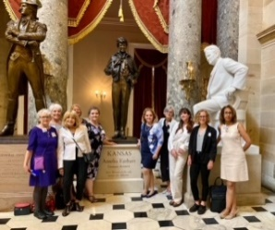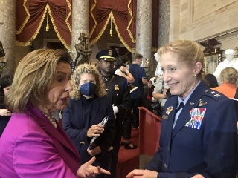
Unveiling of the Amelia Earhart statue at the Capitol Rotunda on July 22,2022

Bev D. Sharp Aviation Outreach Award. - Recurring and NEW topics of interest:
It was agreed that we would be changing the name to: “ The Bev D. Sharp Aviation Outreach Award”. This is considered to be a “less DEI” title which would allow more funding donations. We still have funding issues.

Bev D. Sharp Aviation Outreach Award Updates: Barbara informed the group about progress. Our Bev D. Sharp Aviation Outreach Award will be similar in style and organization as nine (9) other Ninety Nines Awards, including the “George Puttnam Award” and the “Catherine Wright Award”. The selection of winners would be done by the Ninety Nines. There is ongoing cooperation between the International Board of Directors in Oklahoma City and our Washington DC Chapter.

On 12/28/25 Glenna Blackwell, NE Section Nominating Committee Chair, announced that she wished to step down from active involvement with the Award. Glenna said she remained committed to the good ideals, but wanted to step back from active participation and she provided Barbara with notes and ideas for future necessary steps with the international group.

II Past – Last month’s December aviation events:

December 3, 2025, Wednesday. Greater Washington Business Aviation Association (GWBAA) Holiday Gala. Good cheer and conversation were shared at Solace Brewing Company.at Trade West Drive Suite 100 Dulles, VA. It was lovely evening.
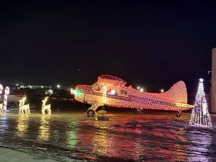.  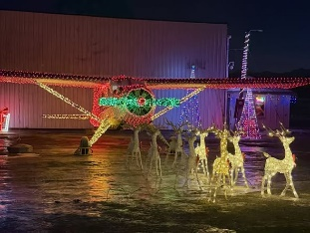

December 4 Thursday. Holiday Party at College Park Aviation Museum. We partied, along with the pilots from EAA-4 College Park (the pilots who organize the yearly Oshkosh) at the College Park Aviation Museum. There was discussion about the new FAA Mosaic regulations. At this pot luck event, there was holiday music, plenty of yummy food, flying inspired frivolity.
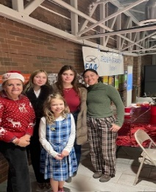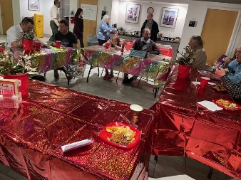

We welcomed four (4) new Ninety Nines Washington DC chapter members. Welcome !! YEAY
1. Raisa Wacker who is studing in an aviation mechanic program
2. Anastasia Kapustina and
3. Katya Mamoutkine who both work at “Pilot in Training Flight Academy” at GAI
4. And another new 99s: Natia
5. And Susan Gardner, 10 yr old, whose father Peter, says is “obsessed by all things aviation”. She signed up for Spring Discovery flights with the EAA-4. She was knowledgeable about Amelia and wants to be a pilot in 6 yrs. So now we have two Washington DC chapter “Jr. 99s” : Susan along with our Charlotte Palagi.

December 6 Saturday at College Park Aviation Museum Santa Fly In at - KCGS

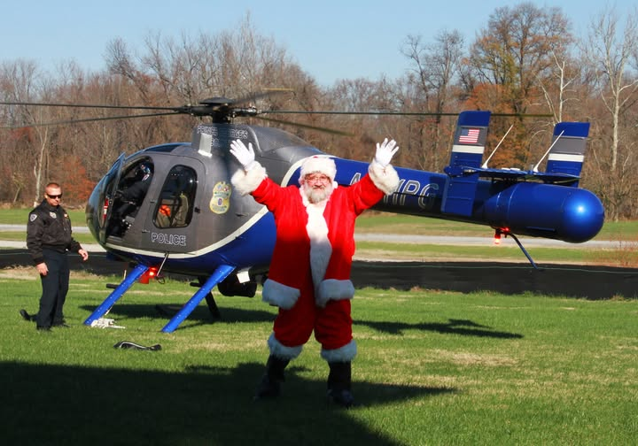

Santa got a ride from the Maryland Police helicopter squad. Santa was joined by the Berwyn Ballet School (that performed excerpts from the Nutcracker), local food vendors, and fun and festive crafts and activities. At the College Park Aviation Museum there is a lovely toy train “College Park Polar Express” and antique toy display. This is an enormous, huge, museum-wide, exhibit event put together by loyalists from the “National Capital (Train) Trackers” group. It has train station depots with little benches, Fed Ex stations, a tiny GA airport stop, Swiss chalets, a University of Maryland stop, assorted churches with bell towers and stained glass windows. Snow, mountains, hills…..for children of all ages.

December 10 Wednesday Holiday Luncheon at Gaithersburg - KGAI. A merry and bright Holiday Luncheon was quickly organized to fete the holiday at Sophie’s Café at Gaithersburg Airport – KGAI. We all raised our Norwegian Glogg mulled-beverage to celebrate the good news of Debi’s airplane! It was a nice lively lunch and participants were able to recount recent flying adventures.


Wash DC Chapter holiday lunch 2025 (OLD PHOTO) holiday lunch 2022 ?

« December 13, 2025 Saturday. Tangier Island Holly Run 2025. This was our Washington DC Chapter’s December Fly out. It was rescheduled to Dec 13, due to the Dec 6 snow (and problems to clean the rwy at TGI).

These great event photos are credited to our wonderfully talented Paige Detwiller, the CSP photographer.
Her firm is Remsberg Inc.; they are a MD based photography & videography company, specializing in MD stories. Their web page has some SPECTACULAR general aviation art/portrait photographs. Thank you !

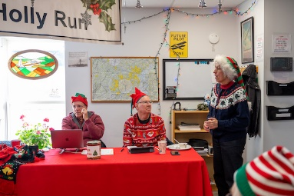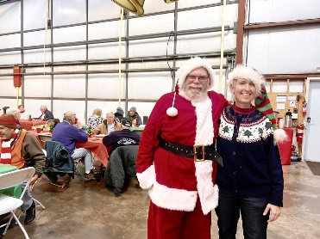

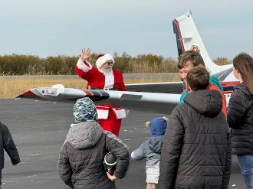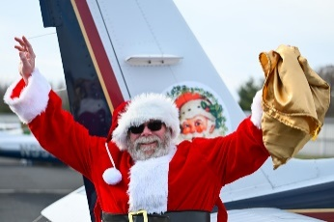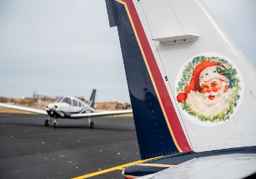

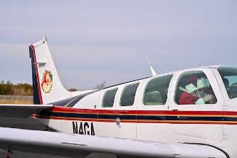

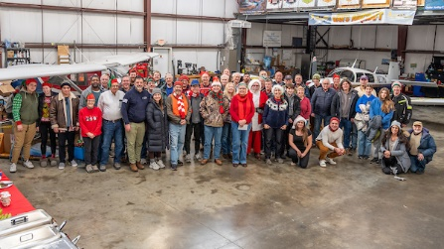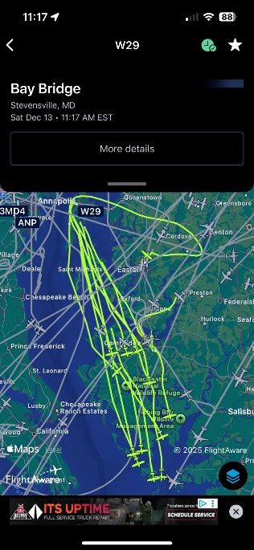
Elf Flotilla 2025 Class photo Reindeer Flotilla (on Foreflight)
….led by “Rudolph One”
A hearty salute to our favorite “Elf Director”, Helen Woods of the Chesapeake Sport Pilot at W29 and this year’s flying Santa. Helen organized the donation of art supplies, materials and gifts for the residents. After a pancake breakfast and pilot briefing to instruct the flotilla, the 2025 Tangier Holly Run began from Bay Bridge Airport in Stevensville MD to deliver holly branches, school supplies and Christmas presents for Tangier, VA school children and shut in residents.
This year 2025, Santa arrived in a Beechcraft Bonanza, decorated to suit Santa Claus, with a one day (FAA approved) Tail Name: “Rudolph One”. “Rudolph One” led about 21 Reindeer planes. FAA, Tracon, local airports were made aware of this invasion to the tiny TGI runway. Multiple Santa elves assigned to help park the Reindeer Planes. The TGI children who helped direct parking and directed elves were given peppermint sticks.
Helen Woods, has organized, sponsored and led the effort for many years. She reported that the 2025 airlift raised over $11,000. for the Tangier Church Roof construction fund. Elves filed and delivered 75 gift bags to very grateful elderly shut-ins on the Island. The population of the island has drastically diminished.
While this year's focus has been on Tangier's 75 shut-ins, a number of you have asked about supporting the school. The Tangier Combined School currently has 39 kids enrolled from pre-K through high school. They would love some art supplies. If you would like to donate to the school, you can either bring art supplies with you or have them shipped (water ferry) directly to the school at: Tangier Combined School; 4375 School Lane; Tangier, VA 23440.
Some of the elves enjoyed lunch at the oldest restaurant on Tangier Island, “Loranines” known for oyster dishes. Due to the sudden invasion of pilots, our arrival at the various restaurants had to be coordinated. The local minister has an ecumenical prayer service at the building which has a lovely white wood historic bell spire.

Due to global warming, the island is sinking into Chesapeake Bay and the permanent census of the island decreases each year. There is NO medical attendant on the island. It is not a solution to simply raise the houses (most which are now out of plumb and sagging) but it is a question of completely revamping the infrastructure, plumbing, water supply, electric connections. Meanwhile there are completely NEW man-made islands at golf course at Haines Point, expensive luxury housing in Dubai, airport in Taiwan and luxury housing Fisher Island in the Miami Florida bay. Even to re-do the infrastructure is a costly notion that has no financial backing in MD so KTGI’s days are numbered. These solutions require major land fill, expensive concrete sea walls, and EPA and government backing for these projects; With the dwindling census at TGI, the MD votes are not present.

December 13, 2025 Saturday 8:45 AM - Santa arrived at FDK airport - festival. NACC building, KFDK. Santa (suspiciously similar to Carlo) and Mrs Santa (suspiciously similar to Lin) will be present to be merry, cheerful and bright. Last year there were fancifully decorated elves (suspiciously similar to Brenda, Carole and Beth) who provided merriment and elf cheer. And, remember, KFDK is a delightful historic old city; nice to see as a Fly out.

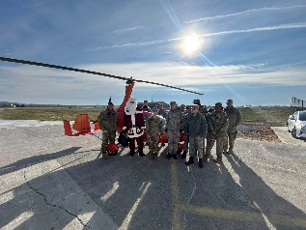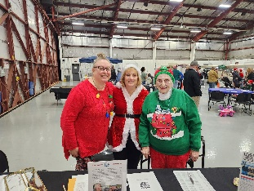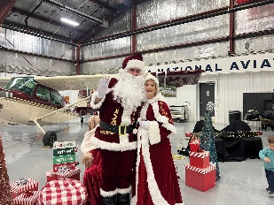

What stylish and festive Holiday Elves! Elves, Santa and Mrs Santa in their best holiday finery!
Beth, Lin, Carole Carlo, Lin

III. This month’s January events:
January 10, 2026, Saturday. VIP tour of Udvar Hazy (1 PM at front desk) - Exclusive Behind-the-Scenes Tour; EAA Chapter 4 – Mary Baker Engen Restoration Facility; Udvar-Hazy Center, near Dulles Airport. ( Due to the government shut down, this tour was re-scheduled) Join us for a rare opportunity to step behind the scenes at the Mary Baker Engen Restoration Hangar at the Udvar-Hazy Center. Unlike the standard museum tour, this visit will showcase the meticulous work of restoring historic aircraft—an inspiring look at aviation preservation in action. This special VIP tour should last 90 minutes, with plenty of time for questions. Learn more about the facility: Mary Baker Engen Restoration Hangar: (https://airandspace.si.edu/visit/udvar-hazy-center/mary-baker-engen-restoration-hangar). This is a VIP tour, with a docent and we need RSVP.
If you want to go, you need to give Lucy your name by Thursday 1/8/26, you can not just show up.
--
IV. Future GA aviation events: February Veronika is planning on February and March fly outs & speakers.

Other future events:
April 8, 2026 – 2 PM-7 PM. Greater Washington Business Atlantic Aviation Assoc. GWBAA at Dulles airport. This is a great opportunity to network with other airplane – pilots
This GWBAA Open House & Aircraft Display event hosted by Atlantic Aviation at Washington Dulles International Airport (IAD).

This open house will feature aircraft tours from industry’s premier manufacturers, with additional aircraft announcements coming soon. It’s a great opportunity to connect with peers, explore the latest aircraft on display, and spend time on the ramp in a relaxed setting. Guests will also enjoy food and beverages from some of the area’s best local vendors, conveniently located adjacent to the outdoor aircraft display. (This may be a good place to network for Bev Sharp Opportunity Award). Hint hint.

May 2026 - Mid Atlantic Spring Section meeting – (hosted MD chapter)

July 6-12 2026 - International Conference meeting. San Diego, CA (hosted by the SW Section)

October 2027 - International meeting Sydney, Australia (hosted by the Australia Section).
For laughs, I looked online, now expired since it had to be bought by December 31, 2025….. Quantas Airlines from IAD, has 65 destinations across Australia (deal $835 round trip for October 2027).

Puppy Rescue: Race 4 Life Rescue did a remarkable job rescuing shelter pets and flying supplies to hurricane-impacted areas. Volunteers needed to fly airport-legs to save puppies, (and full grown) from hurricane affected areas. Questions to Erin Miller. Learn more about them here: https://raceforliferescue.org/.
Hurricane Helene and Jamaica relief: The Operation Air drop pilots is working with individual donation groups to do emergency flights to assist needy residents of the Ashville, NC and of the Jamaica areas. Hurricane Helene has caused much destruction and GA airplanes have been asked to help drop off needed supplies. https://www.operation-airdrop.com/hurricane-helene. We have been asked to donate GA flight time.

FLYOUTS and aviation events schedules:
To be as inclusive as possible, and to promote all women pilots and student pilots, we extend a flyout invitation to the sister Sugarloaf 99s and to the Bravo Flight School should they want to join the fly outs. I reached out to Lin Caywood, Sugarloaf Chairman and she was in support of joint fly outs. TBD.
Next Washington DC Chapter Meeting: First Monday of February 2, 2026, via Zoom at 7:30 PM.
End of agenda. *************

